USER GUIDE

Search PATIENT types

August 2018

Version 1.01

Pharmacon ITC303/309 Group

Document Revisions

|  |  |  |
| --- | --- | --- |
| Date | Version Number | Document Changes |
| 30/08/2018 | 1.01 | Draft |
|  |  |  |
|  |  |  |
|  |  |  |
|  |  |  |
|  |  |  |
|  |  |  |
|  |  |  |
|  |  |  |

Table of Contents

1 Introduction 4

1.1 Scope and Purpose 4

1.2 Process Overview 4

2 Search Patient Types 5

2.1 Login – Administration User 5

2.1.1 To Log in to Pharmacy Error Tracker (PET): 5

2.1.2 To Search for a Patient Type: 6

2.2 Patient Type Update 8

# Introduction

## Scope and Purpose

The purpose of this user guide is to provide instructions on how to search for an patient type that has already been entered. No other features of the Pharmacy Error Tracker (PET) application will be discussed in this user guide.

* To be able to use PET, the user will need basic knowledge of logging into an online application and using a search function to locate records.
* This feature is only available to a user with administrator rights.

## Process Overview

The administrator will need to log into PET using their valid username and password.

* The Welcome Page will be presented on successful login.
* The administrator will need to select Search Patient Types via the menu bar or the button on the menu page.
* The user is to enter a search criterion.

# Search Patient Types

To search for a patient type, the user will need to launch the application, login with a valid user name and password with administration rights. Using the search bar, the user will be able locate an patient type or multiple patient types relating to the search criteria entered.

## Login – Administration User

User must have access to the application.

User must have a valid username and password with administration rights.

### To Log in to Pharmacy Error Tracker (PET):

1. Launch the application.
2. Click in the Username field.
3. Enter username.
4. Tab or click in Password field.
5. Enter password.

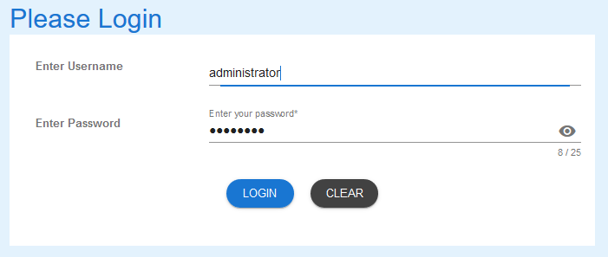

1. Select LOGIN to access PET.

NOTE:

Users entering an invalid username and/or password will not beable to access PET.

### To Search for a Patient Type:

1. From the Welcome Page, there are two ways to navigate to “Search Patient Types”:
   1. Select the “Search Patient Types” from the list

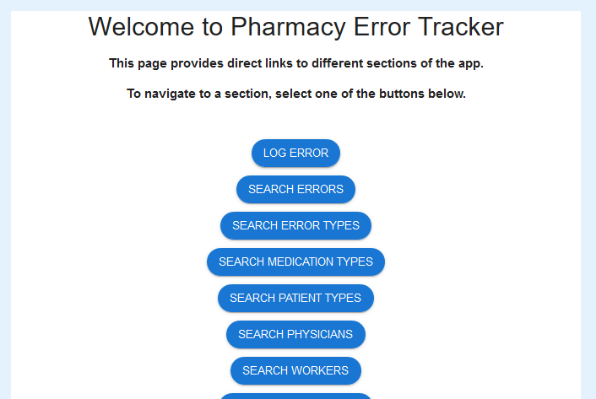

* 1. From the Menu Bar, hover your mouse over “Search…” and select “Search Patient Types”



1. A list of patient types in the database will appear, showing the first five (5) entries.

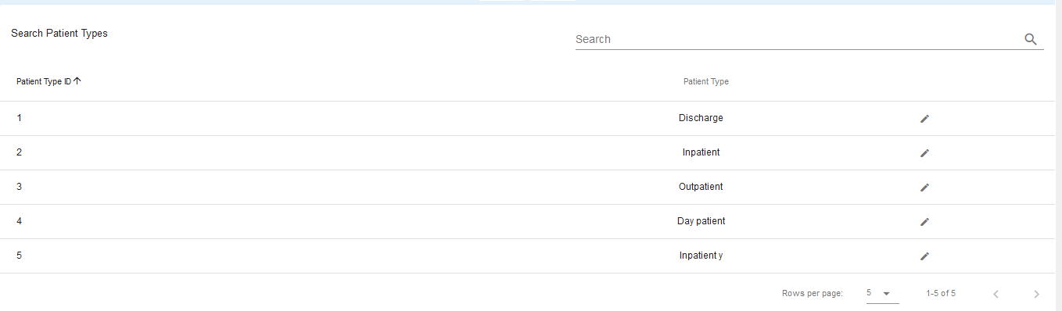

* 1. To change the number of records being shown, click on the drop-down arrow at the bottom-right corner and select number of records you wish to see.



1. To search for a specific record, enter the criteria in the search field located at the top-right corner.



1. The search criteria entered will find any record that matches that criteria in the fields shown in the headings. Entering a more detail criteria will narrow the number of records that are returned. Entering “d” returns 2 records of those available.  
     
   By entering “da” the search is narrowed further.

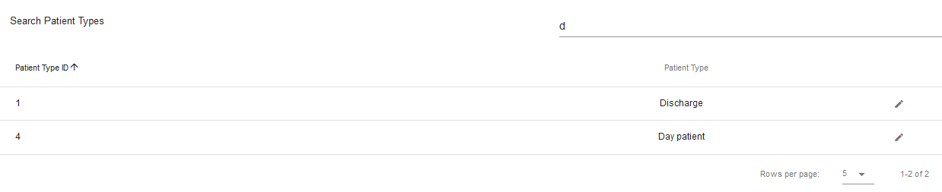

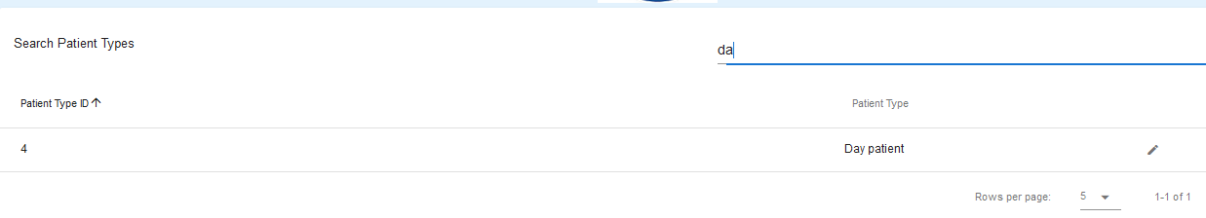

1. To search for another patient type record, repeat from step 1b.

## Patient Type Update

Patient types can be loaded into the Patient Type Details form from a search, be amended and the record in the database updated. Please see the **User Guide - Update Patient Types** for instruction.

If you encounter issues not addressed by this user guide, please contact your account manager for additional support.